Kaitlyn Dominguez

Dr. Rivas

Final Project Milestone

April 2, 2017

**Introduction:**

For my final project, I developed a Java application that allows users to edit their photos. This application lets users to filter their images by adjusting the size, rotation, brightness, structure, and contrast. This application allows people to make subtle yet drastic changes to their pictures. It differs from the other photo editing apps you can find online because it creates subtle changes to an image. The goal of the application is to allow the user to edit the picture so that it does not look like it has had any retouching done. These filters will still make the photo look natural and realistic unlike some of the other image filtering apps. It is perfect for someone who loves photography and wants to enhance the pictures they take without making it seem like the photo was edited. This application also aims to help pictures taken on a cell phone look like they were taken on a professional camera. Personally, I love taking pictures on my cell phone because it’s easy! You always have it with you and you don’t have the hassle of carrying a big camera around everywhere. While cell phone cameras have improved over the last few years, they still don’t compare to professional cameras. By enhancing the colors and structure, the image looks a lot more professional than a cell phone picture.

For example, look at Image A and Image B. Image A is a picture that I took of a golden plate while I was Spain a year ago. Image B is the same image only with slight edits to make the picture look more professional. As you can see, I cropped the image a bit to get rid of the counter in the background. Then I edited the brightness in the picture to make the gold in the plate stand out more. Finally, I edited the structure to emphasize all the detailing on the beautiful plate. These changes are small, yet they completely change the photo. They make it look more professional and help capture the beauty of the picture. Image A can easily turn into Image B with this application.

Image A: Image B:

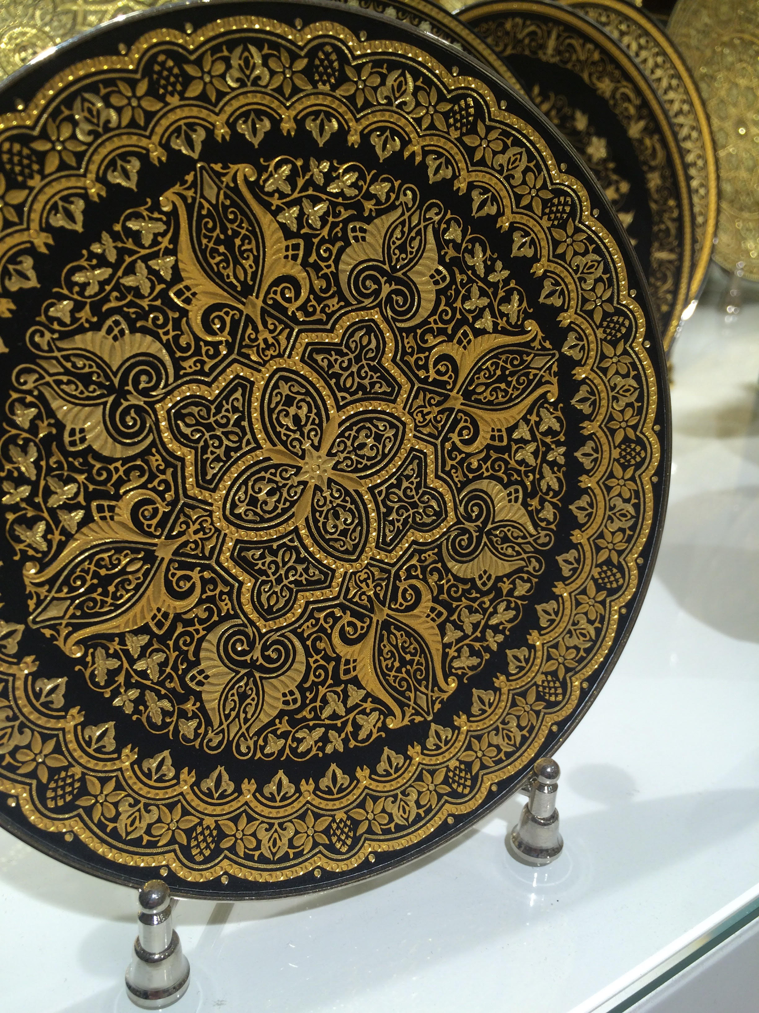 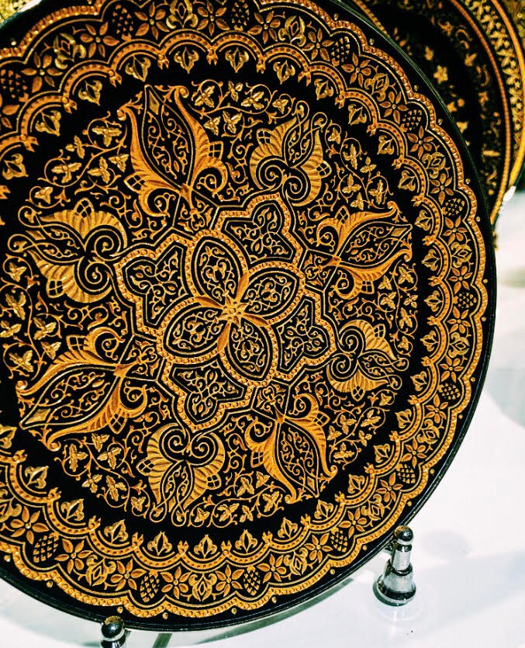

**UML Diagram:**

|  |
| --- |
| Image Editor* |
| Image:  BrightnessValue: double  StructureValue: double  ContrastValue: double  CropDimensions: array |
| ImageEditor*()  editImage()  crop()  rotate()  brightness()  structure()  contrast() |

* Still need to make a unique name for the application

**Progress:**

So far, I have coded uploading the picture to Java and loading it in the application. This process was not the easiest, it required a lot of trial and error. I still need to code the actual editing features. I am hopeful that this will go smoother than the first half of the project did. I believe I will like that part more than figuring out how to upload an image to the application because it will involve editing pictures. I am excited to find out how it all works.

**Conclusion:**

Overall this application is easy for photographers to use to edit their photos or for users to use to enhance their cell phone pictures. As someone who loves taking pictures both on my phone and on a camera, I can use this application to take my photos to the next level. There are plenty of applications that do filter images but usually the edits in those apps are very visible to people looking at the picture. The goal of this application is to enhance a picture while making sure if someone looked at the photo, they wouldn’t immediately think that it is edited. I had the goal in mind to make my own pictures look professional through this application and I am excited to use this on my own pictures!